1. Can we create an Activate/Deactivate button for the shows. It will be the following shows for each park:

Universal Studios Florida

|  |  |  |
| --- | --- | --- |
| Woody Woodpacker’s KidZone | Entertainment | Universal Studios |
| Ollivanders Wand Shop | Entertainment | Universal Studios |
| Curious George Goes to Town | Entertainment | Universal Studios |
| A Day in the Park with Barney | Shows | Universal Studios |
| FEAR FACTOR LIVE | Shows | Universal Studios |
| Universal's Superstar Parade | Shows | Universal Studios |
| Universal's Orlando Cinematic Celebration | Shows | Universal Studios |
| Universal Orlando's Horror Make Up Show | Shows | Universal Studios |
| The Blues Brothers Show | Shows | Universal Studios |
| The Tales of Beedle the Bard | Shows | Universal Studios |
| Animal Actors on Location | Shows | Universal Studios |
| Celestina Warbeck and the Banshees | Shows | Universal Studios |

Islands of Adventure

|  |  |
| --- | --- |
| Poseidon's Fury | Show |
| Frog Choir | Show |
| Oh! The Stories You'll Hear! | Show |
| Triwizard Spirit Rally | Show |
| Dark Arts at Hogwarts Castle | Entertainment |
| Ollivanders Wand Shop | Entertainment |
| Raptor Encounter | Entertainment |
| The Nighttime Lights At Hogwarts Castle | Entertainment |

1. On the back end can you also make it so that we can filter down based on the show

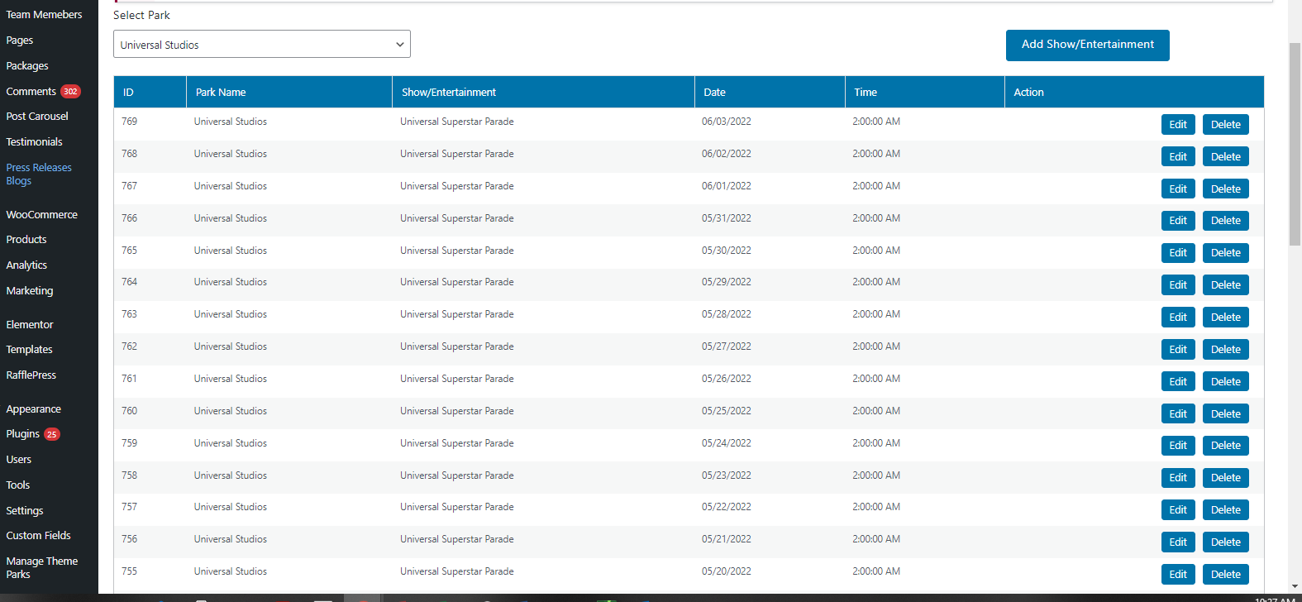

1. For islands of Adventure please remove these shows from the “Ride List”

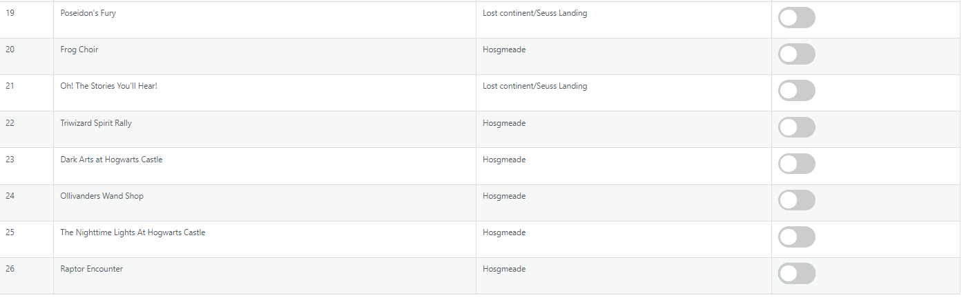

1. Please update the spelling of ride#5 Hagrid's Mafical Creatures Motorbike Adventure it should be “Hagrid’s Magical Creatures Motorbike Adventure”

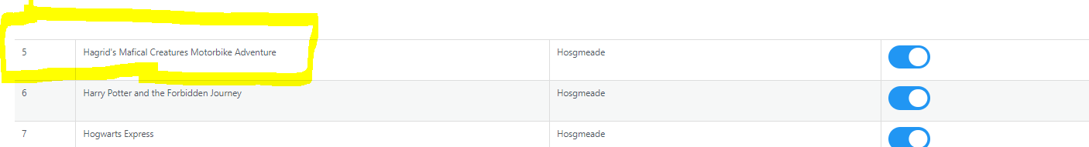

1. Can we put a calculation in place that when the ride is in the same land to always use 5 minute walk time?

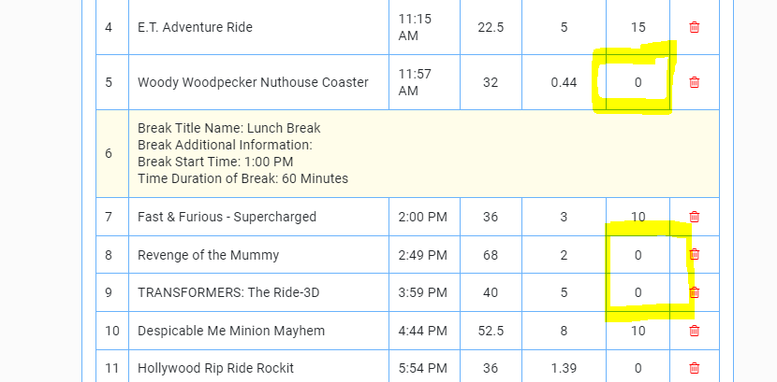

1. I don’t think it’s clear that guests can move around the boxes can we please add arrows on the right hand side and have it save move up – move down like this

